Bahria University,

Karachi Campus



LAB EXPERIMENT NO.

**08**

LIST OF TASKS

|  |  |
| --- | --- |
| TASK NO | OBJECTIVE |
| 1 | **CreateProcess that run your current execution file (parent process) with and child process(notepad), display versionId, ThreadId, processId of both parent and child process.** |
| 2 | **CreateProcess that run your current execution file (parent process) with and child process(MSword), display versionId, ThreadId, processId of both parent and child process.** |
|  |  |

Submitted On:

**26/12/2022**

**Task # 01: CreateProcess that run your current execution file (parent process) with and child process(notepad), display versionId, ThreadId, processId of both parent and child process.**

**Solution:**

#include<iostream>

#include<Windows.h>

using namespace std;

int main(){

HANDLE hprocess=NULL;

HANDLE hthread=NULL;

STARTUPINFOW si;

PROCESS_INFORMATION pi;

DWORD dwProcessId=0;

DWORD dwthreadId=0;

ZeroMemory (&si,sizeof(si));

ZeroMemory(&pi,sizeof(pi));

DWORD Ret=0,dwPID=0,dwTID=0,dwPver=0;

dwPID=GetCurrentProcessId();

cout<<"GetCurrentProcessId: "<<dwPID<<endl;

dwTID=GetCurrentThreadId();

cout<<"GetCurrentThreadID: "<<dwTID<<endl;

cout<<"Command Line:%s\n"<<GetCommandLine()<<endl;

dwPver=GetProcessVersion(dwPID);

cout<<"Get Process Version: "<<dwPver<<endl;

cout<<"Starting another process i.e. child process\n"<<endl;

BOOL bCreateProcess=CreateProcessW(L"C:\\Windows\\System32\\notepad.exe",NULL,NULL,NULL,FALSE,0,NULL,NULL,&si,&pi);

if(bCreateProcess==false){

cout<<"Failed"<<endl;

}

cout<<"Create process successfully"<<endl;

cout<<"ProcessId"<<pi.dwProcessId<<endl;

cout<<"ThreadId"<<pi.dwThreadId<<endl;

return 0;}

**Output:**

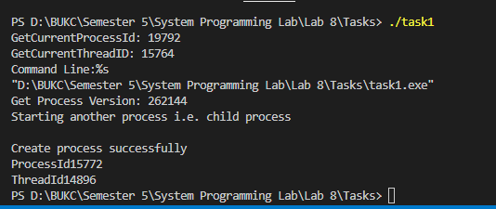

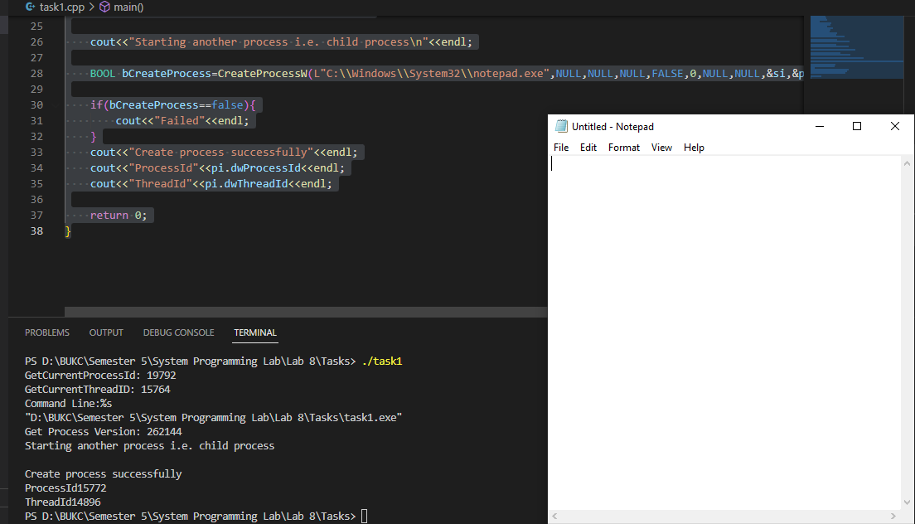

**Task # 02: CreateProcess that run your current execution file (parent process) with and child process(MSword), display versionId, ThreadId, processId of both parent and child process.**

**Solution:**

#include<iostream>

#include<Windows.h>

using namespace std;

int main(){

HANDLE hprocess=NULL;

HANDLE hthread=NULL;

STARTUPINFOW si;

PROCESS_INFORMATION pi;

DWORD dwProcessId=0;

DWORD dwthreadId=0;

ZeroMemory (&si,sizeof(si));

ZeroMemory(&pi,sizeof(pi));

DWORD Ret=0,dwPID=0,dwTID=0,dwPver=0;

dwPID=GetCurrentProcessId();

cout<<"GetCurrentProcessId: "<<dwPID<<endl;

dwTID=GetCurrentThreadId();

cout<<"GetCurrentThreadID: "<<dwTID<<endl;

cout<<"Command Line:%s\n"<<GetCommandLine()<<endl;

dwPver=GetProcessVersion(dwPID);

cout<<"Get Process Version: "<<dwPver<<endl;

cout<<"Starting another process i.e. child process\n"<<endl;

// BOOL bCreateProcess=CreateProcessW(L"C:\\Windows\\System32\\notepad.exe",NULL,NULL,NULL,FALSE,0,NULL,NULL,&si,&pi);

BOOL bCreateProcess=CreateProcessW(L"C:\\Program Files\\Microsoft Office\\Office16\\WINWORD.exe",NULL,NULL,NULL,FALSE,0,NULL,NULL,&si,&pi);

if(bCreateProcess==false){

cout<<"Failed"<<endl;

}

cout<<"Create process successfully"<<endl;

cout<<"ProcessId"<<pi.dwProcessId<<endl;

cout<<"ThreadId"<<pi.dwThreadId<<endl;

return 0;

}

**Output:**

